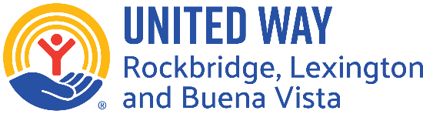
218 South Main Street, P. O. Box 1094, Lexington, VA 24450

May 6, 2026

Dear Community Partners,
The United Way of Rockbridge (UWR) is pleased to announce that we are now accepting funding applications for the 2027 Calendar Year. UWR is committed to collaborating with the charitable community to improve the quality of life for all residents in Rockbridge County, Lexington and Buena Vista. We strive to be a leader in assessing community needs; to raise and allocate resources for other organizations; and to ensure the appropriate use of those resources. UWR’s vision is to ensure equity in education, health, and financial well-being for all Rockbridge community members.

While we will fund a wide range of projects, UWR has identified two specific focus areas where we would like to make a substantial impact. Those areas are early childhood development and the support of ALICE (Asset-Limited, Income-Constrained, Employed) households. Additionally, we will continue to place high value on grant applications that demonstrate collaboration with other community partners.

Once applications are submitted, UWR will work with community reviewers to visit your agency to learn more about your project July 8-17. Recommendations and a review of all applications will be completed and funding approved in September. Agencies will be informed of those funding decisions by October 1.

We are grateful to live in a community blessed with so many wonderful initiatives and innovative programs. It is a delight to support agencies and projects committed to improving the lives of Rockbridge residents.
Sincerely,
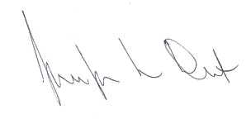
Jennifer Dent
UWR Executive Director
Application Instructions:
Please include the following documentation along with your completed application.
- List of board members and other key personnel
- Approved agency budget and balance sheet as of 12/31/2025
- Most recent financial review and/or audit
- Proposed budget for the project
- Any relevant recent publicity and/or marketing materials
- Signed Statement of Understanding

If you are a new applicant, please ALSO include the following.

- Commonwealth of Virginia Certificate of Corporate Status
- 501c3 IRS Certification
- By-Laws
- A copy of your most recent 990

The application package is due no later than 5:00 p.m., Monday, June 29, 2026 to the UWR office: 218 S. Main St., Lexington, VA 24450 or email: director@uwrockbridge.org.

